Computer Networks Laboratory Week 2

Name : Tanishq Vyas
SRN : PES1201800125
Section : H
Semester : 5
Branch : CSE

Server IP : 10.0.8.5
Client IP : 10.0.8.4

Serial No. | Type of Connection | Time Taken
1. | Non-persistent | 1.80536696
2. | 2 - persistent | 1.43986980
3. | 4 - persistent | 1.42705418
4. | 6 - persistent | 1.41677463
5. | 8 - persistent | 1.43011502
6. | 10 - persistent | 1.57620063

Answers :

The persistent connections have lesser time when compared to non persistent connection since only one request is allowed over there while in persistent connections we are allowed to make multiple request over the same channel since its kept alive.

Optimal number of persistent connections : 6

This is the optimal number of connections because we get the least amount of response time for this.

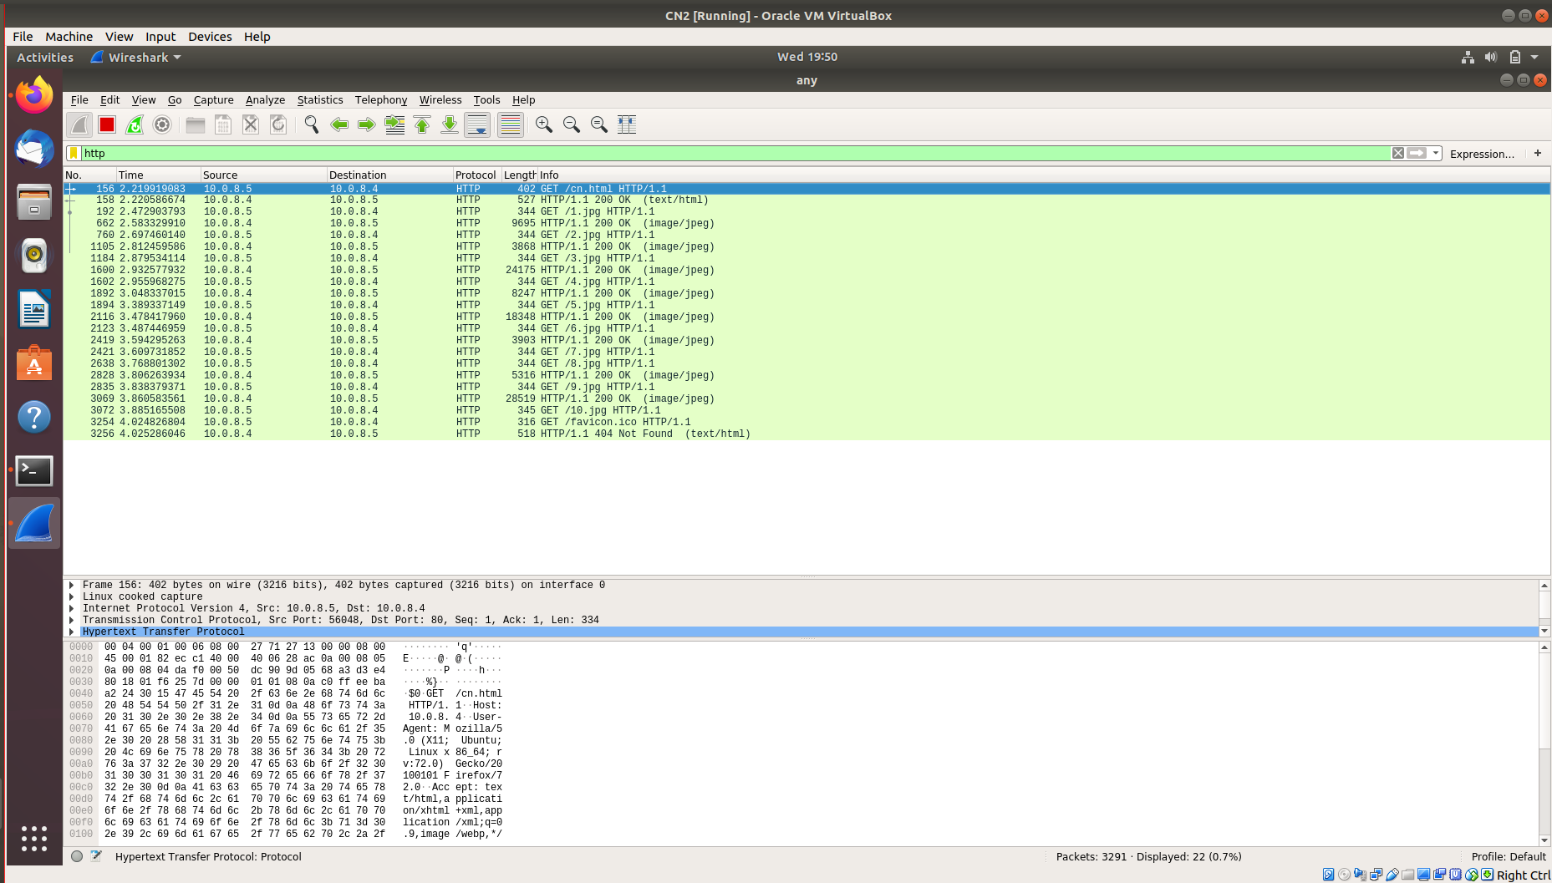
Wireshark Capture : Non Persistent Connection

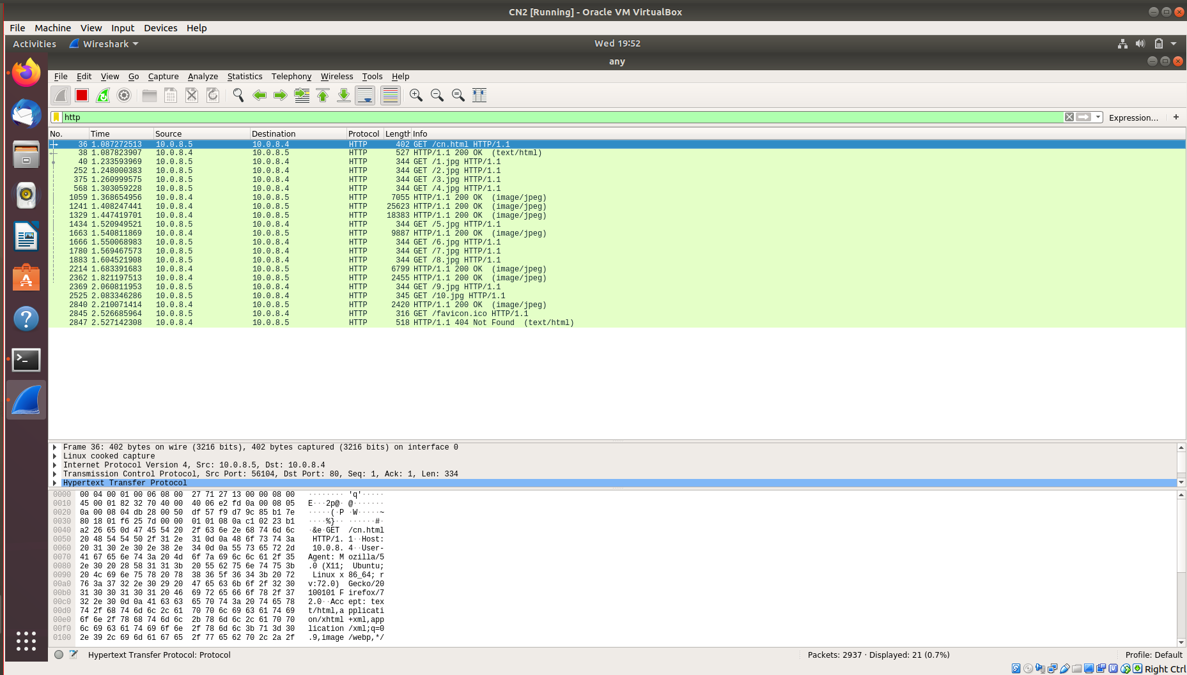

Wireshark Capture : 2 Persistent Connections

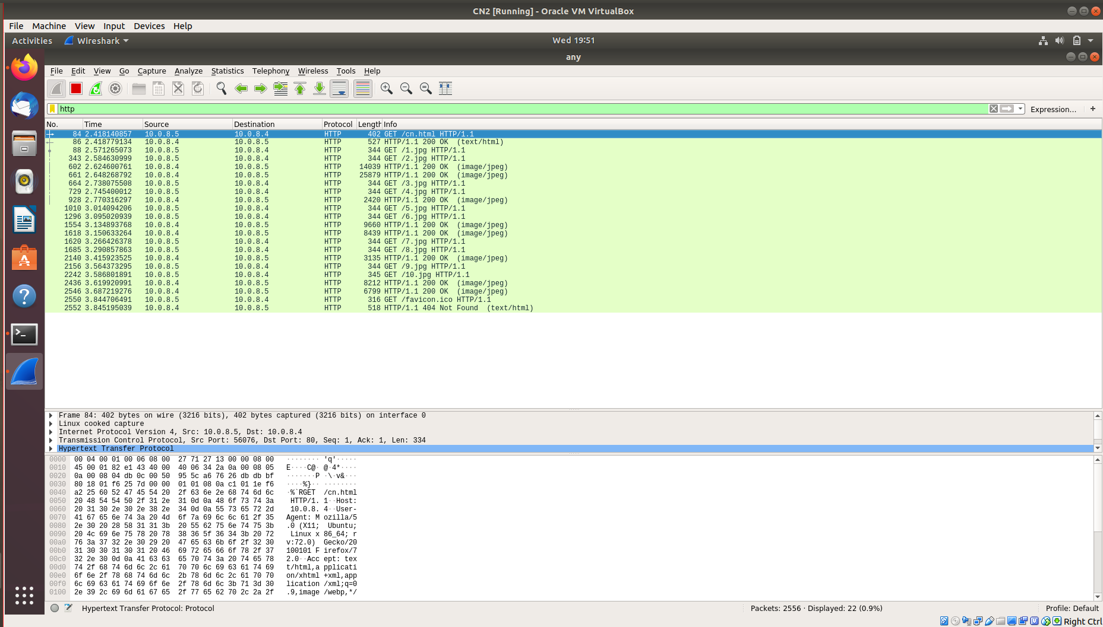

Wireshark Capture : 4 Persistent Connections

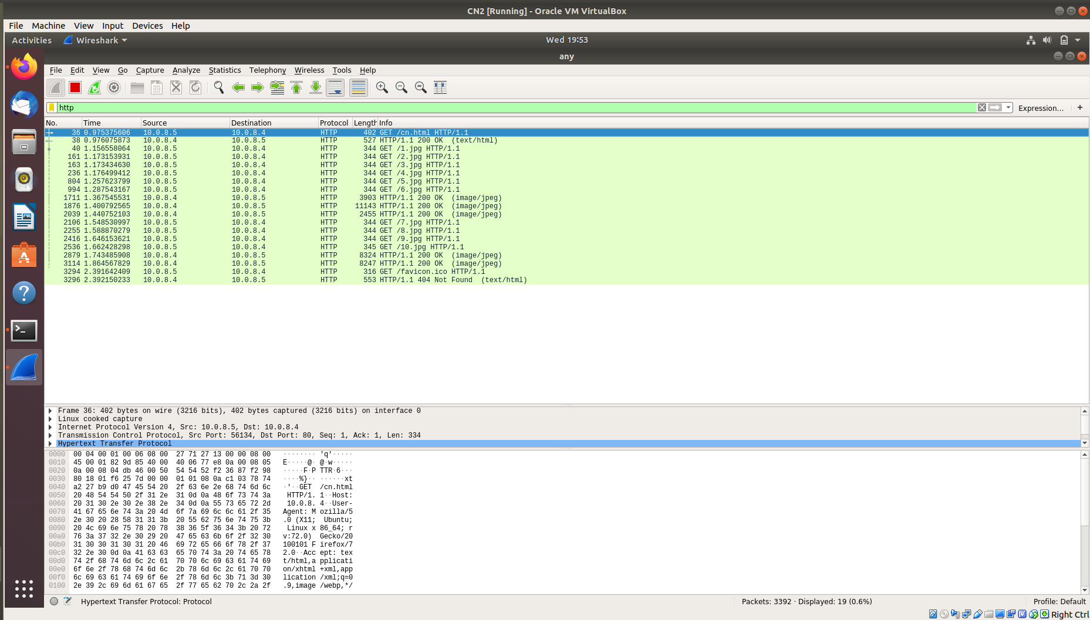
Wireshark Capture : 6 Persistent Connections

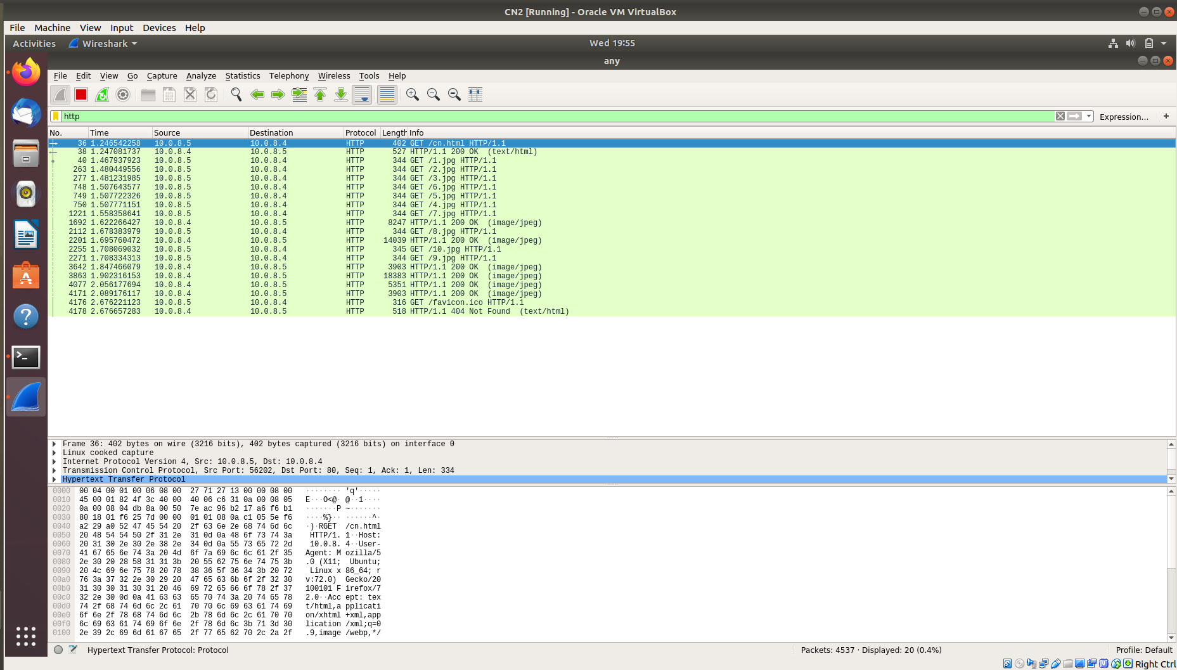
Wireshark Capture : 8 Persistent Connections

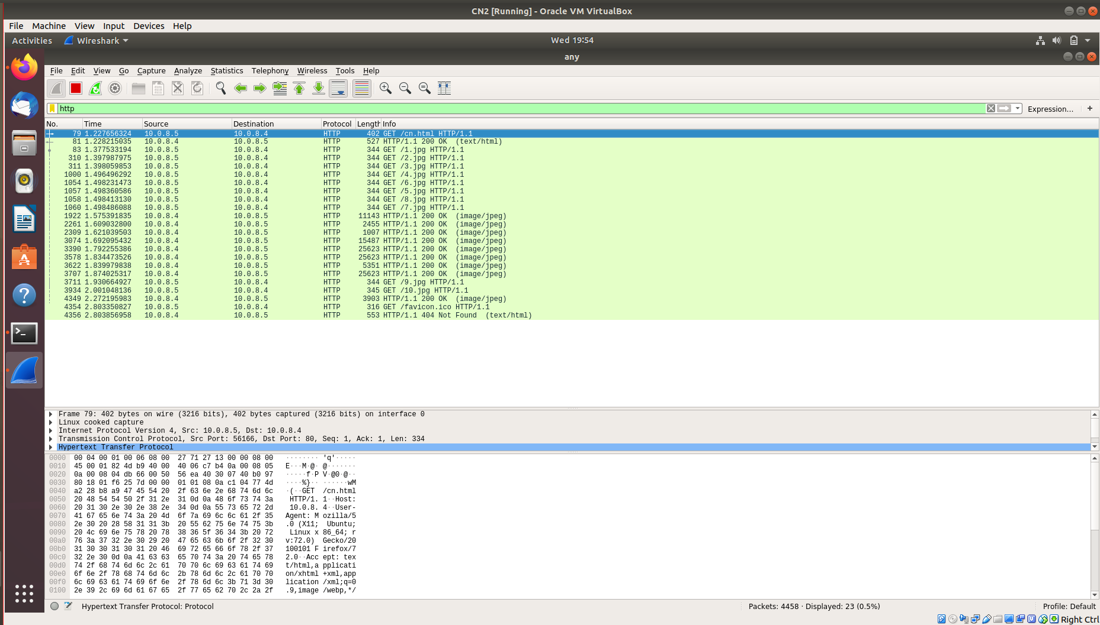

Wireshark Capture : 10 Persistent Connections

